Final Report - Second Draft

**1. Introduction**

**3.1 Locking mechanism [Neal Traynor]**

This section discusses the findings pertaining to the locks for the recumbent tricycle.

Our class project that was assigned was to create a recumbent tricycle, with the ability to be usable in the winter. Each team is focusing on a specific area of the design. My team is responsible for designing the frame and body of the tricycle. My specific job is to find a way to incorporate a locking mechanism and security system for the bicycle.

**3.1. Initial goals and engineering Principles**

The first thing that came to mind when designing a fully enclosed recumbent tricycle was to make it as much like an automobile as possible. This is because I believe people will be more willing to buy our design if it was as much like a car as possible. If one can immediately get comfortable and used to the recumbent tricycle, more units will be sold. As a result, I decided that the best way to make the bike secure would be to incorporate a vehicle door lock into the tricycle door. This leads to a few research questions that need to be answered. For instance, what is the feasibility of being able to acquire a door lock for the project? If I get one, how exactly would it be mounted to the door in order to function properly? Finally, what will the weight and size of the lock, and would these statistics be acceptable for the final design of the recumbent tricycle? For a start, I defined three ~~engineering principles~~ parameters that would solve the three research questions, and create the best locking mechanism for the tricycle: Simplicity, durability, and effectiveness. By applying these three ~~principles~~ parameters I am able to make a design that will work as needed.

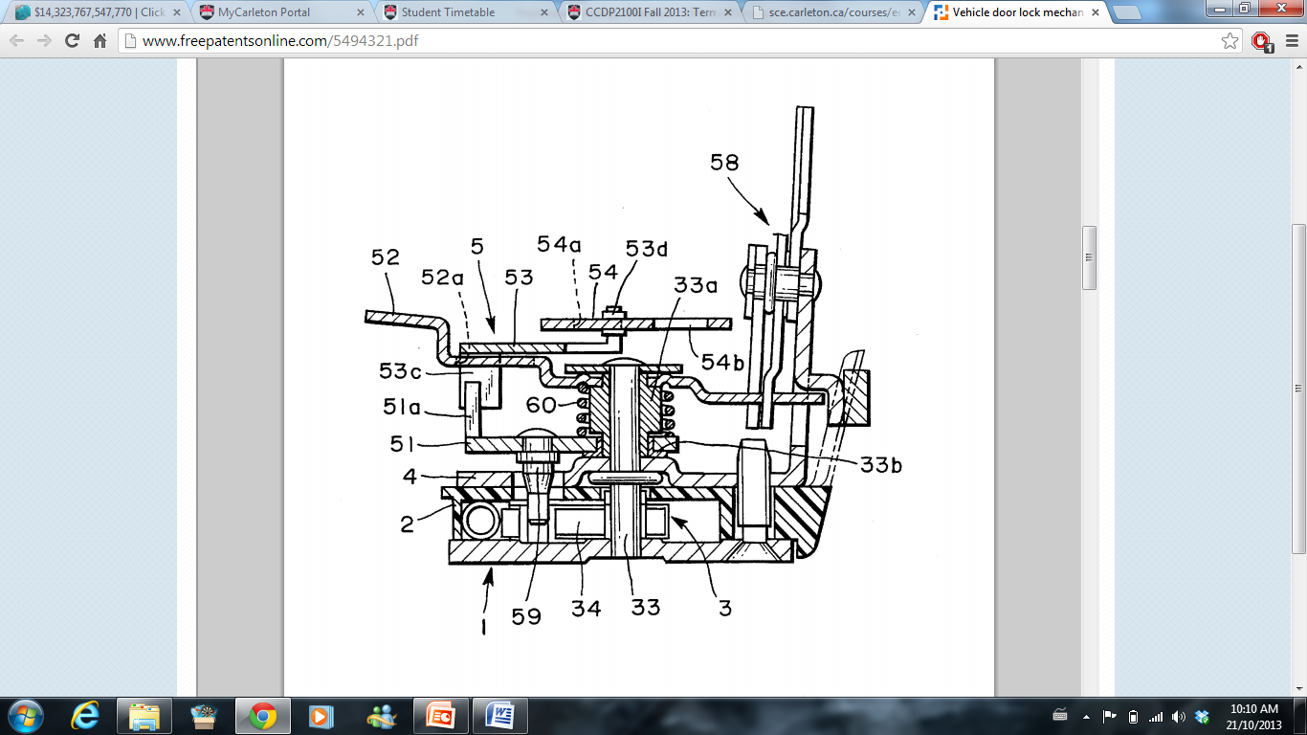**3. Findings**

After doing preliminary research, I found that taking the existing automobile lock and modifying it to fit in the bicycle door can be done. By searching through a site called 'freeonlinepatents.com', I found a patent for a vehicle door lock that is very similar to what would be needed[1]. The locking mechanism (US Patent 5 494 321) was designed specifically to be as compact as possible. By modifying the conventional lock, the 2 inventors were able to remove unneeded parts, thus saving space. As a result, the mechanism is smaller and lighter - perfect for the recumbent tricycle. This then gives the user additional options for security. For instance, one could the user could buy a keyless entry system for the tricycle. Also, one could buy what's called 'the club' from a store such as Canadian tire[2]. This locks the steering wheel in place, so that the vehicle cannot be driven away if it is broken into. Finally, As some of my classmates and colleagues have pointed out, it would be very feasible to make it available to lock the bike with a standard bike lock. The bike could be locked via the exposed back wheel, or via a pair of holes drilled into the side of the bike outer shell of frame. The only problem, however, is to do this a pole or bike rack is needed to attach the bike to. As a result, unless our design becomes very widespread, few cities will want to install bike racks specifically for our vehicle on the side of the road.

This is Patent No. 5 494 321. (Figure 1)

Once the design was chosen, the next task is to find a way to acquire a vehicle door lock. If the design became widespread, and there were a lot of potential buyers, the best thing to do would be to contact a car manufacturer, and buy the locks ~~en masse~~ in bulk. However, for our purposes, we could contact some local mechanics and talk to them about getting just one unit. A place of business I was referred to is called 'Kenny-U PULL'[3]. This is basically a chop shop, where car parts can be bought or sold.

Finally, Until I get the exact design specifications, or a copy of the design itself, I need to have a rough estimate of the size and weight of the locking mechanism. From day to day observations, The total size would be about 450mm X 450 mm. This includes the locking mechanism itself (figure 1), as well as the connections to the door handle and electronic wirings. The bulk of the weight will be in the locking mechanism, and since our door will be smaller than most car doors, the majority of the connections can be scrapped. Overall, the end weight should be no more than 20 pounds, or about 9kg.

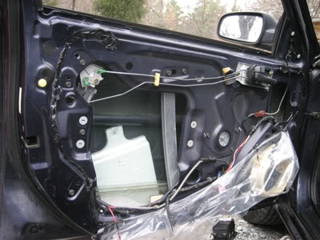

This is an example of the complete mechanism. As you can see, most of the space is take up by the connections to the locking mechanism, the door handle, etc. This can be shortened to fit in the door of our recumbent tricycle. (Figure 2)

References

1. Hiroshi Ishihara, Yoshinobu Ogura, "Vehicle Door lock mechanism", US Patent 5 494 321, Feb 27 1996
2. Canadian Tire, Vehicle anti-theft devices, http://www.canadiantire.ca/AST/browse/4/ [Auto/AutoSafetySecurity/VehicleAntiTheftDevices.jsp](http://www.canadiantire.ca/AST/browse/4/Auto/AutoSafetySecurity/VehicleAntiTheftDevices.jsp), (Accessed: October 19, 2013)
3. Kenny U-PULL, *Kenny U-PULL,* <http://www.kennyupull.net/index.php>, (Accessed: November 13, 2013)